December 1, 2025
Subject: Bradford Soil and Water Conservation Dates for FAR publication
To:
Florida Department of Agriculture and Consumer Services/Office of Agricultural Water Policy c/o Yesenia Escribano, Bureau of Policy, Planning and Coordination Chief:
Yesenia.Escribano@FDACS.gov
To:
Bradford County Commission - Bradford County Manager Scott Kornegay: scott_kornegay@bradfordcountyfl.gov
Submitted electronically
As voted on in meeting on November18th 2025, the Bradford Soil and Water Conservation District has approved their 2026 meeting dates and times. On the following page please find the listing as submitted for publication in the Florida Administrative Register
Please let me know if any further information is required as soon as possible.
Thank you,
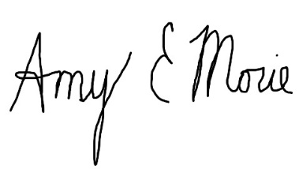
Amy Morie, chair
Bradford Soil and Water Conservation District

The Bradford Soil and Water Conservation District announces a public meeting to which all persons are invited.
DATE AND TIME:
January 6, 2025, 4:30 PM,
January 20, 2025, 10:30 AM,
February 3, 2025, 4:30 PM,
March 3, 2025, 4:30 PM,
April 7, 2025, 4:30 PM,
May 5, 2025, 4:30 PM,
May 19, 2025, 10:30 AM,
June 2, 2025, 4:30 PM,
July 7, 2025, 4:30 PM,
August 4, 2025, 4:30 PM,
September 1, 2026 4:30 PM,
September 15, 2026, 10:30 AM,
October 6, 2026, 4:30 PM,
December 01, 2026, 4:30 PM,
December 15, 2026, 10:30 AM
January 5, 2027, 4:30 PM
PLACE: 2266 N Temple Ave., Starke, FL 32091
Subject: Items for discussion include general business pursuant to responsibilities under Chapter 582, F.S., and any new business that is brought up by District supervisors. A copy of the agenda may be obtained by contacting: Bradford Soil and Water Conservation District at (904) 966-6224
There will be no meeting November 03, 2026, in observance of Election Day

