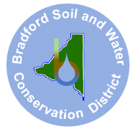Bradford Soil & Water Conservation District
2266 Temple Avenue
Starke FL 32091
www.bradfordsoilandwater.org
(904) 966-6224

Minutes November 4, 2025, Meeting
Meeting called to order 4:35 p.m.
Bradford Agricultural Center, Starke, Florida

Attending: Supervisors; Amy Morie, Walt Westcott; Ok Sun Burks. Guests: Paul Still, volunteer, Kathy Still, Vicky Sweat; Joanne Tremblay by ZOOM.
Motion by Walt Westcott to approve draft minutes from 10/7/2025. Ok Sun Burks seconded. Motion approved by vote 3, 0.
Motion by Walt Westcott to authorize Chair, Amy Morie, to write a request to Bradford County Board of Commissioners to release annual funds to BSWCD. Ok Sun Burks seconded. Motion approved by vote of 3,0.

The meeting adjourned at 5:42 p.m.

Minutes submitted by Ok Sun Burks, secretary.

Approved in meeting November 18, 2025

