7 July, 2025

Subject: Request for comment to be read

To: Suwannee River Water Management District – Board of Directors

Bradford Soil and Water Conservation District (BSWCD) requests the following to be read into the record at the 7/8 board meeting of the Suwanee River Water Management District (SRWMD).

At their board meeting of 7/1/2025, BSWCD was made aware of continuing conditions of the SRWMD Edwards Bottomlands Mitigation Project as increasing the risk of upstream flooding above Alligator Creek of the Mitigation Project. In the interest of the health, safety, and welfare of Bradford County’s people and the healthy functioning of its waters and soils, the district voted to express their concerns.

The Board invites further discussion of the project with Suwanee River Water Management District. BSWCD is open to potential working agreements that could be included in BSWCD’s annual plan as mitigation measures to partner with SRWMD’s management for this site and further the protection of Bradford County’s residents and natural resources.

Respectfully,

Amy Morie, District 2

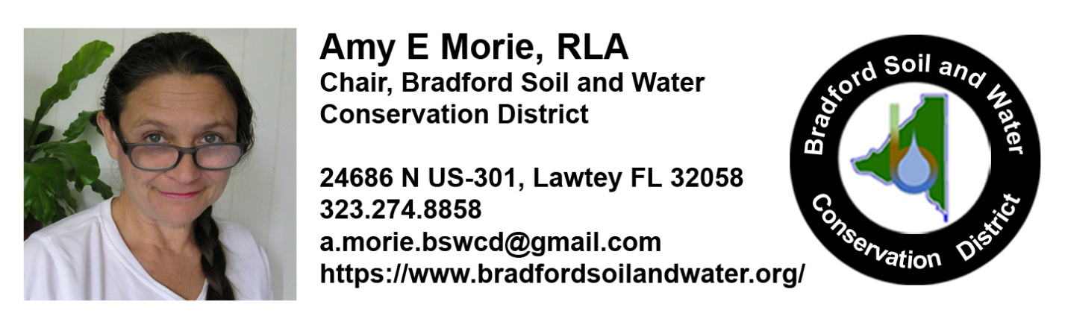

Please note that Florida has a very broad public records law. As a result, any written communication created or received will be made available to the public and media, upon request, unless otherwise exempt. Under Florida law, e-mail addresses are public records. If you do not want your e-mail address released in response to a public records request, do not send electronic mail to this office. Instead, contact our office by phone or in writing.