Draft

Request from Bradford Soil and Water Conservation District for an Extension of Time to file a Petition for an Administrative Hearing

This is a Request from Bradford Soil and Water Conservation District for an Extension of Time to November 25, 2024 to file a Petition for an Administrative Hearing related to the Chemours Industrial Wastewater Permit for the Florida Mine- Trail Ridge FL0000051-015-IW3S as provided for under Rule 62-110.106(4), F.A.C.

Bradford Soil and Water Conservation District has a substantial interest in the renewal of the Chemours IWW Permit because of the potential flooding of Alligator Creek upstream of the Suwannee River Water Management District’s Edwards Bottomlands Project on Alligator Creek in the City of Starke and the potential contamination of Alligator Creek with radium levels in excess of the 5 pCi/L limit.

The request for an extension of time is needed because the DEP responses to issues raised in the meeting held on August 1, 2024, were emailed to Amy Morie Bradford Soil and Water Conservation District Chairperson on October 16, 2024. Bradford Soil and Water Conservation District and the Intent to Issue documents were noticed in the in the 10/24/2024 issue of the Telegraph, Times, Union. The next meeting of the Bradford Soil and Water Conservation District was scheduled for 10/5/2024. As a Special District covered by Florida Sunshine Rules the Bradford Soil and Water Conservation District Supervisors could not the Chemours Draft Permit outside the noticed 10/5/2024 meeting.

Responses to records and document requests to DEP resulting from the October 16, 2024, email will be needed to draft the Administrative Hearing Petition.

*The following information is presented to support the need for the extension:*

*The DEP responses and the Fact Sheet information indicate four significant issues still exist with the Chemours IWW Permit.*

1. *The integrity of the system that caries mine contact water from the West Levee to the IWW treatment facility and the movement of the mine contact water outside of the IWW permit boundary*
2. *The discharge of industrial wastewater over and under the rail line that forms the southern boundary of the Chemours IWW system*
3. *The failure of Chemours to establish that Alligator Creek after the Edwards Bottomlands project channel modifications has the capacity to carry 40 MGD of Chemours discharges without causing flooding in the City of Starke and eastern Bradford County*
4. *The permit provides adequate measures to ensure water with Radium levels in excess of the 5 pCi/L limit will not be discharged to Alligator Creek and the Keystone Lakes.*

*Still Comments*

*The wording “the portion of Alligator Creek which flows south in Clay County” appears on Page 1 of the Notice of Intent to Issue, Page 1 of the Notice of Draft Permit and Page 2, of the Draft Permit. The use of the word “portion” in the phrase “the portion of Alligator Creek which flows south in Clay County” is misleading because it makes it appear that the Alligator Creek that receives the discharges from D-001 and the Alligator Creek that receives the*

*D-002 discharges are the same creek. The Alligator Creek that receives water from D- 001 flows to the Santa Fe River in the SRWMD while the Alligator Creek referenced for D-002 flows to the St Johns River and is in the SJRWMD. The two creeks have no physical connection. There is a third Alligator Creek that flows from Lawtey to the New River that also has no physical connection.*

*Delete the word “portion of” so it reads “the Alligator Creek which flows south in Clay County”.*

*Fact Sheet Errors*

*Addendum to Fact Sheet*

*First page*

On August 1, 2024, the Department staff met Mr. Mr. Paul Still and Ms. Amy Morie to address their comments/concerns on the draft permit documents.

*Still Comments*

*Amy Morie did not attend the August 1, 2024, meeting.*

*Fact Sheet*

Page 5 of 123

Figure 1: Chemours – Trail Ridge Mine Location

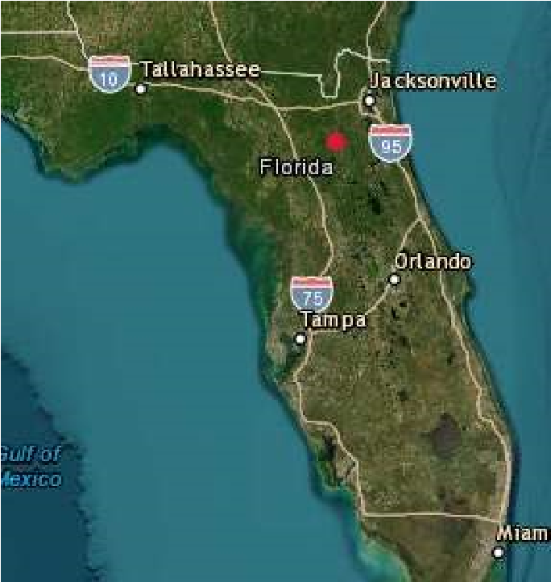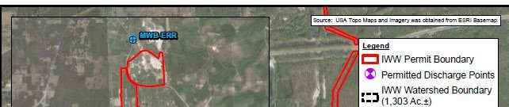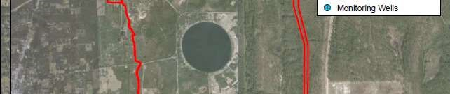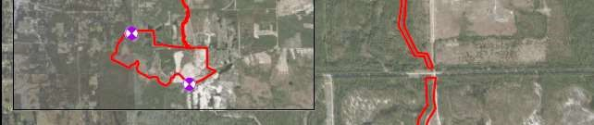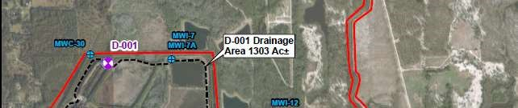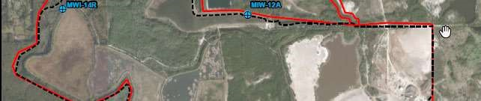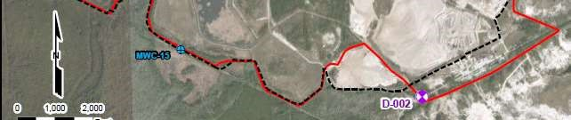

*Still Comments*

*Has DEP verified that the drainage ditch that connects the south end of the West Levee impoundment exists? The path of the ditch is not clear in Google Earth imagery.*

*Who produced Figure 1, DEP or Chemours?*

Page 6 of 123

Figure 3

: Process Flow Diagram

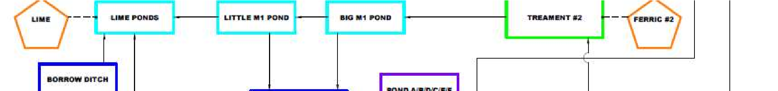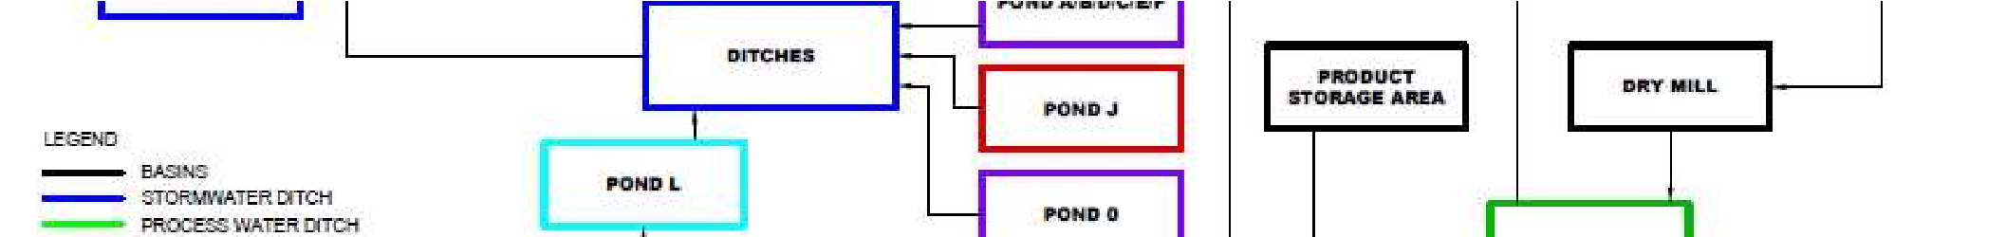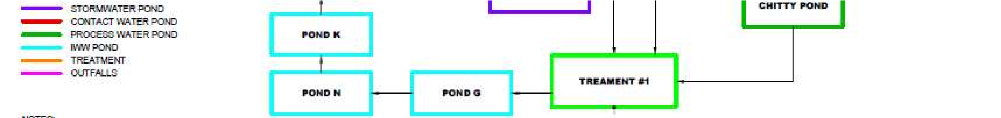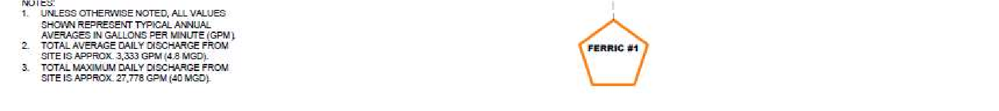

*Still Comments*

*Figure 3 does not show the discharges from the base of Pond G over and under the rail bed and the discharges from the Borrow Ditch over and under the rail bed. The average and maximum flows noted do not match other data in the Fact Sheet.*

*Who produced Figure 3, DEP or Chemours?*

Page 7 of 123



*Still Comments*

*The Figure titled TR Pond System Water Balance at Maximum Discharge – 40 MGD does not have a number. It does not show the discharges from the base of Pond G over and under the rail bed and the discharges from the Borrow Ditch over and under the rail bed. The location of the Southern Wetland is unknown. The Barrow ditch system runs from Pond G to Pond L. The Figure fails to indicate the size of the rain event that would produce the 40 MGD discharge.*

*Who produced the above Figure, DEP or Chemours?*

Page 9 of 123

Page 9 of 123

|  |  |  |  |  |
| --- | --- | --- | --- | --- |
| Parameter | Units | Max/Min | Reported Value | Statistical Basis |
| Whole Effluent Toxicity | percent | - | - | - |
| Flow | MGD | Max | 79.2* | Max Daily Value |
| Solids, Total Suspended | mg/L | Max | 15.0 | Max Daily Value |
| Iron, Total Recoverable | mg/L | Max | 1.84 | Max Daily Value |
| Radium 226 + Radium 228, Total | pCi/L | Max | 1.4 | Max Daily Value |
| pH | s.u. | Max | 6.58 min – 8.23 max | Max Daily Value |
| Zinc, Total Recoverable | mg/L | Max | - | Max Daily Value |
| Nickel, Total Recoverable | mg/L | Max | - | Max Daily Value |

Note(*): Maximum daily flow in response to Hurricane Irma, September 11, 2017 to September 13, 2017

*Still Comments*

*The Table fails to provide a time period included in the data and appear not to have recent or current data. The Radium level for 2023 was reported as 3 pCi/L.*

*The Max Daily Value for flow is an error. The 79.2 MGD flow rate was based on a time period of less than 24 hours. The use of the 79.2 MGD should be removed throughout the Fact Sheet.*

Page 9 of 123

 Chemours – Trail Ridge Mine

1. Facility History:

Mining and ore processing at the Chemours – Trail Ridge began in the early 1990s.

*Still Comments*

*Mining began in the early 1950s.*

Page 11 of 123

Outfall D-001

|  |  |  |  |  |  |  |  |  |  |
| --- | --- | --- | --- | --- | --- | --- | --- | --- | --- |
| Parameter | Permit Limit | Limit | Avg | Mod | Med. | 95th Per. | Max | Skew | Stand Dev. |
| Flow (MGD) | AA | Report | 4.15 | 4.00 | 4.40 | 5.70 | 6.30 | -0.46 | 1.14 |
| MA | Report | 4.18 | 3.10 | 3.20 | 9.58 | 20.60 | 2.23 | 3.37 |
| Max | 40.0 | 10.20 | 4.20 | 7.50 | 24.62 | 79.20 | 4.20 | 9.98 |
| Total Suspended Solid (mg/L) | Max | Report | 6.35 | 5.00 | 5.00 | 11.00 | 33.00 | 4.13 | 4.19 |
| MA | Report | 4.68 | 5.00 | 5.00 | 6.90 | 12.80 | 1.08 | 1.75 |
| Iron, Total Recoverable, mg/L | Max | 1.00 | 0.95 | 0.90 | 0.90 | 1.80 | 3.10 | 1.03 | 0.54 |
| Nickel, Total Recoverable, µg/L | Max | H.B. | 0.007 | 0.003 | 0.003 | 0.025 | 0.080 | 4.093 | 0.017 |
| Zinc, Total Recoverable, µg/L | Max | H.B. | 0.014 | 0.010 | 0.010 | 0.050 | 0.052 | 2.975 | 0.012 |
| Mercury, Total Recoverable, µg/L | Max | 0.012 | 0.050 | 0.025 | 0.025 | 0.093 | 0.100 | 1.732 | 0.035 |
| Radium 226 + Radium 228, Total (pCi/L) | Max | 5.0 | 2.543 | 2.700 | 2.700 | 2.970 | 3.000 | -1.156 | 0.456 |

A review of the discharge flow through D–001 indicates that the 95th percentile and maximum value of the annual average daily flow are 5.70 MGD and 6.30 MGD, respectively; the 95th percentile and maximum value of the maximum daily flow are 24.62 MGD and 79.20 MGD, respectively. One time exceeding the permit limit is 40 MGD maximum daily flow, with the value of 79.20 MGD during Hurricane Irma (September 2017). Because of the impacts of Hurricane Irma (i.e. Category 5 hurricane), Governor Rick Scott on September 9, 2017 signed Executive Order 17-235, declaring a statewide state of emergency. DEP issued an emergency authorization for Repairs, Replacement, Restoration and Certain Other Measures made Necessary by Hurricane Irma, OGC No. 17-0989 dated September 10, 2017. Within the Emergency Area (Bradford, Clay and other counties) the requirements and effects of statutes and rules which conflict with the provisions of the Order were suspended to the extent necessary to implement this Order.

Normal Distribution of Maximum Daily Flow

Number Value: 71

Mean: 10.20

SD: 9.98

Median: 7.50



*Still Comments*

*The use of the flow rate of 79.2 MGD in the Table and graphs should be corrected. The 79.2 MGD was observed for a period of less than 24 hours.*

*Who produced the above figures DEP or Chemours?*

Page 12 of 123

 Prior to the development of the City of Starke, Alligator Creek was a small, intermittent stream, which received seepage and overland flow from the area’s mixed pine and hardwood forests. Over many decades, Alligator Creek was dredged several times prior to environmental regulation to improve the drainage within the City of Starke. These dredging events have caused hydrologic impacts to the floodplain wetlands and destabilized the stream in many locations causing continued erosion and water quality problems. Stream restoration is needed to improve wetland functions within the Alligator Creek floodplain and protect this system from continued erosion and degradation, but the funding of such a restoration has been cost prohibitive. In order to improve hydrologic conditions within the floodplain and reduce some of the sediment load from going to Lake Rowell down Alligator Creek, Suwannee River Water Management District (SRWMD) in cooperation with the Florida Fish & Wildlife Conservation Commission (FWC) and the City of Starke, plan to conduct a floodplain restoration project which will re-establish the flow connection from the a portion of the altered creek to a 47-acre floodplain parcel known as the Edwards Bottomlands. The restoration project will improve water quality, fish and wildlife habitat and the hydrology within the altered wetlands. SRWMD is also evaluating the potential acquisition of a 14-acre tract of historic floodplain, adjacent to the 47 acre parcel, as part of this project.

*Still Comments*

*The highlighted section does not reflect that that the Edwards Bottomlands Project earth work was completed in 2018.*

Page 13 of 123

 Alligator Creek has a contributing drainage area of 19.4 square miles. Low-flow frequency of the creek is following: 7Q2 = 3.2 ft3/s, 7Q10 = 0.3 ft3/s, 30Q2 = 8.0 ft3/s; 30Q10 = 1.1 ft3/s. There is a SRWMD and USGS stage station at Alligator Creek below US 301 in Starke, Station ID: 02320734 (reference document: USGS Drainage Areas of Selected Surface water sites in Florida, Report 81-482, 1981).

*Still Comments*

*The 1981 report would not represent the current area contributing flow to Alligator Creek. Low flows are not the issue of concern.*

Page 13 of 123

 The contribution to the watershed for Alligator Creek (waterbody ID # 3598c) was reviewed for a 25 year-24 hour rainfall event and a 100 year 24 hour rainfall event and considered the discharge from the Trailridge mine outfall, D-001. The Chemours TrailRidge mine percent contribution ranged from 0% at no outfall discharge to 2.30 % for the 79.20 MGD during Hurricane Irma (September 2017). During Hurricane Irma (September 2017) the rainfall was well beyond the 100-year storm event and thus the Chemours discharge as a percentage of total would be even less than 2.30 %.

|  |  |  |  |
| --- | --- | --- | --- |
| Discharge from D-001 | | Flow from Outfall D-001 as Percentage of Total Flow | |
| MGD | Volume | Storm Event 24-hr/25-yr = 7.75 in  3.49 x 108 gallons Stormwater | Storm Event 24-hr/100 yr = 10.0 in  4.51 x 108 gallons Stormwater |
| 0.0 | 0.0 | 0.00 % | 0.00 % |
| 20.0 | 2.67 x 106 | 0.76 % | 0.59 % |
| 30.0 | 4.01 x 106 | 1.13 % | 0.88 % |
| 40.0 | 5.35 x 106 | 1.51 % | 1.17 % |
| 50.0 | 7.39 x 106 | 2.07 % | 1.61 % |
| 70.0 | 9.35 x 106 | 2.61 % | 2.03 % |
| 80.0 | 10.68 x 106 | 2.96 % | 2.30 % |

*Still Comments*

It is not clear how the Total Flow of “Storm Event 24-hr/25-yr = 7.75 in 3.49 x 108 gallons Stormwater” and the “Storm Event 24-hr/100 yr = 10.0 in 4.51 x 108 gallons Stormwater” event were calculated.

*The analysis is flawed because the percentage of flow represented by D001 flows would increase as you move upstream from the 301 bridge. The highest of flow would occur and flooding would occur upstream of the bridge. No information was provided for the flooded section of Alligator Creek upstream of the 301 bridge.*

Page 45 of 123

***DEP Response:*** *Chemours has monitored the water quality before discharging from Outfall D002, and due to the high elevation of the trip mines (i.e. “the old mined area”), water discharging from the Outfall D-002, would not flow through the old mined area. The water discharging from the Outfall D-002 should mostly flow through a drainage ditch running along the side of the Treat Road to the Blue Pond (Please see Figures 1 and 2 below).*

*In addition, FDEP and SJRWMD have monitored the water quality of the pond (please see Figure 3 for the monitoring location) and attached Appendix D for the analytical sample results.*

***Figure 1:***

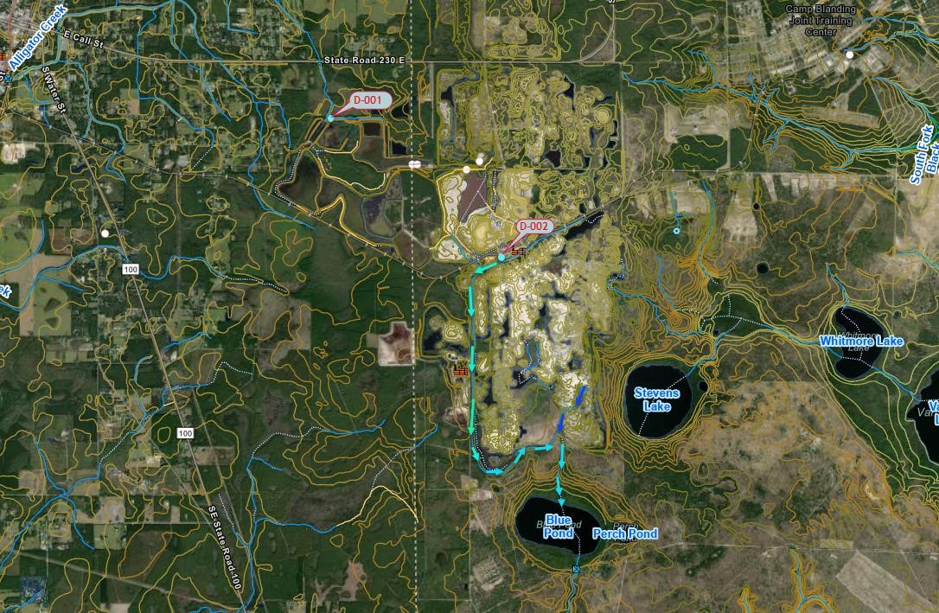

*Still Comments*

*The areal imagery indicates that stormwater from the old mined area would also flow into the ditch along Treat Road. To protect Blue Pond and the downstream Keyston Hights lakes water sampling should be done at the point the water enters Blue Pond. Does water enter Blue Pond from a pipeline. That pipeline is not shown in Figure 1.*

*I did not see Radium level data in the Appendix D analytical sample results. Until the source of the Radium in the Train Ridge South water is identified it is possible water flowing through the old mine area could pick up Radium.*

*Who produced Figure 1, DEP or Chemours?*

Page 48 of 123

*Mr. Paul Still’s follow-up comment:* “Emergency conditions would be defined on a case-by-case basis.”  *is still vague. Chemours has the option to shut down operations as they did on January 31, 2024, when there was an offsite release of process water. The risk posed by the potential addition of water from Trailridge South process water with radium levels above the 5piC/L limit creates to great of a risk for residents of Stake whose property would be impacted during flooding events.*

***DEP Response:*** *The water that discharges from the Outfall D-001 is required to comply with the Water Quality Limit of 5 piC/L for Radium 226+228. The historical data including the latest sample result which was collected in December 2023 shows that the total Radium 226+228 was below the WQS of 5.0 piC/L for the parameter. The new permit will increase the sample frequency for Radium 226+228 from an annual (1/year) basis to quarterly (1/quarter or 4/year) basis.**Increasing monitoring frequency will help better characterize the effluent quality and help to detect events of noncompliance****.***

*Still Comments*

*The DEP response fails to define what an emergency condition is. The lack of response by DEP to previous events resulting in pollutant discharges requires a clear definition of emergency conditions.*

*Quarterly sampling would allow 3 months of flow of water that exceeds the 5pCi/L before it is detected. Once the Radium is released to Alligator Creek via D001 there would be no way to treat it and prevent downstream contamination of homes and property.*

Page 50 of 123

• Estimate concentration of total radium 226+228 discharging in the worst-case scenario:

For Trail Ridge: Flow = 30.0 MGD (Average Flow)

Total Radium 226+228 = 2.9 pCi/L (Max value)

For the Trail Ridge South: Flow = 3.0 MGD (Maximum Flow)

Total Radium 226+228 = 9.3 pCi/L (Max value)

In the Combined Discharge:

Radium 226 + 228 = = 3.48

.

×

.

(

.

×

.

)

(

.

.

)

<

5.0

*Still Comments*

*The above would represent the near best-case scenario because it maximizes the dilution of the high levels of Radium in the Trail Ridge South water with the lower levels found in the Trail Ridge water. The annual average flow from D001 noted in the Table on page 11 of the Fact Sheet is 4.15 MGD. Diluting the 3 MGD of Trail Ridge South water with Radium levels of 9.3 pCi/L with 4.15 MGD of Trail Ridge water with 3 pCi/L Radium levels would result in a exceedance of the 5 pCi/L limit.*

Page 50 of 123

*Mr. Paul Still’s follow-up comment:* *What is the source of “* Flow = 30.0 MGD (Average Flow)*”? The annual average flow in the December 2023 DMR was 3.8 MGD. If 3.8 MGD is used in the equation above the 5 pCi/L limit would be exceeded.*

***DEP Response:*** *The calculation demonstrates the worst-case scenario. The water that discharges from the Outfall D-001, is required to comply with the Water Quality Limit of 5 piC/L for Radium 226+228.*

*The December 2023 sample result shows that the Radium 226+228 was 3 piC/L which was below the WQS*. *As discussed above, the new permit will increase the sample frequency of the parameter, which would help to confirm the water quality of the discharge.*

*Still Comments*

*The issue is not the current Radium levels of Trail Ridge discharges. The issue is the potential Radium levels of Trail Ridge discharges if Trail Ridge South discharges are diverted to Trail Ridge. The draft permit language only requires quarterly sampling the permit would allow exceedance of the 5 pCi/L limit for over 3 months before the exceedance was reported. I have not seen any Radium levels for the Trail Ridge South facility since the 9.3 pCi/L level reported in 2023.*

Page 56 of 123

Mr. Paul Still’s follow-up comment: What information did DEP use to support the claim “The stormwater management system at Chemours Trail Ridge was designed based on the Water Management Districts stormwater guidebooks.”?

DEP Response: The stormwater management system was reviewed and approved in the previous permit cycles in accordance with the Applicants Handbook Volume II

*The Edwards Bottomlands Project was not constructed at the time of the “previous permit cycle”. The impacts of the Edwards Bottomlands Project do not appear to have been evaluated for the current permit renewal.*

Page 59 of 123

*Mr. Paul Still’s follow-up comment:* *The above table and conclusions are not valid because they only represent the percentage of flow at Lake Rowell. As you move upstream the percentage of flow from Chemours would increase. Calculations should be done for the segments of Alligator Creek upstream from the following 301, SR 100, Laura Street, SR230, Bradford Court, and NE 17th Ave.*

*(Note the formulas on Pages 59-61 would not copy into the portrait page)*

***DEP Response:*** *The calculations included stormwater runoff from 2.59 square miles of drainage area of Chemours – Trail Ridge and with different discharging capacity from the Outfall D-001.*

***Additional calculations****: Estimate water level of the creek when increasing the flow rate.*

* *Assume that the Alligator is a trapezoid channel: Then*

*Comparation of the water in the creek when the flow rate of the effluent discharge is changing from 30 MGD to 40 MGD*

𝑄1 *= 30.0 MGD, and* 𝑦1 *is corresponding water level in the creek.*

𝑄2 *= 40.0 MGD, and* 𝑦2 *is corresponding water level in the creek.*

*Apply Manning equation for open channel flow:*

* *The above calculations indicate that the water level of the creek may increase 8.5% when the flow rate of the discharge increases from 30.0 MGD to 40.0 MGD.*

*Still Comments*

*The Alligator Creek channel is not a trapezoid and is highly variable and is impacted by the location and elevation of the spoils placed on the banks when the channel was created.*

*The DEP response fails to address the issue that the percentage of flow from the Chemours discharges increase significantly as you move upstream of the 301 bridge over Alligator Creek. Flooding impacts from Irma had the most impacts between the 301 bridge over Alligator Creek and the SR 230 Bridge over Alligator Creek which is where the Chemours IWW canal meets the predevelopment Alligator Creek.*

*Who produced the calculations, DEP or Chemours?*

Page 56 0f 123

*Mr. Paul Still’s follow-up comment****:*** *What information did DEP use to support the claim “*Based on historical data during previous wet periods (i.e.100-year, 24-hour storm rain event) that resulted in the discharge rates, the treatment system has proven to handle the flow rates, meet water quality standards, and not cause downstream flooding.*”?*

***DEP Response:*** *Department staff used water balance calculations as discussed above and reviewed the USGS monitoring data (water elevation level in the creek from 11/13/2012 to 07/29/2024) at USGS Station 02320734 (Alligator Creek at Starke Florida), approximate at latitude 29° 56´ 10´´ N and longitude 82° 06´ 45´´ W.* [*http://www.mysuwanneeriver.org/realtime/river-levels.php*](http://www.mysuwanneeriver.org/realtime/river-levels.php) [*http://www.mysuwanneeriver.org/realtime/river-30-day.php?id=02320734*](http://www.mysuwanneeriver.org/realtime/river-30-day.php?id=02320734)

*And Station 02320732 (Alligator Creek at Starke Florida), approximate at latitude 29° 56´ 10.86792´´ N and longitude 82° 06´ 42.37844´´ W.* [*https://waterdata.usgs.gov/monitoring-location/02320732/#period=P1Y&showMedian=true*](https://waterdata.usgs.gov/monitoring-location/02320732/#period=P1Y&showMedian=true) [*https://pubs.usgs.gov/wri/1993/4165/report.pdf*](https://pubs.usgs.gov/wri/1993/4165/report.pdf)

*Still Comments*

*The* [*Alligator Creek at Starke (noaa.gov)*](https://water.noaa.gov/gauges/acsf1) *link on* [*http://www.mysuwanneeriver.org/realtime/river-levels.php*](http://www.mysuwanneeriver.org/realtime/river-levels.php) *site provides following Historic Crests data for Alligator Creek*

*1. 147.98 ft on 09-11-2017*

*2. 146.99 ft on 08-05-2024*

*3. 146.86 ft on 07-07-2021*

*4. 146.64 ft on 09-21-2021*

*5. 146.33 ft on 12-17-2023*

*6. 145.75 ft on 08-02-2023*

*7. 145.70 ft on 03-24-2022*

*8. 145.49 ft on 09-10-2022*

*9. 145.38 ft on 07-31-2023*

*10. 144.82 ft on 09-10-2022*

*This data indicates the Edwards Bottomlands project may have had a significant impact on Alligator Creek Water levels and the ability of the Alligator Creek to handle 40 MGD of discharges from Chemours.*

Page 56 of 123

*Mr. Paul Still’s follow-up comment:* *What information did DEP use to support the claim* “The stormwater management system at Chemours Trail Ridge was designed based on the Water Management Districts stormwater guidebooks.”?

***DEP Response****: The stormwater management system was reviewed and approved in the previous permit cycles in accordance with the Applicants Handbook Volume II*

*Still Comments*

*The current Chemours IWW permit was issued on June 29, 2017. The Alligator Creek channel alterations in the SRWMD Edwards Bottomlands project were not completed until late 2018. The alterations could not have been evaluated for the June 29, 2017 permit.*

Page 56 of 123

*Mr. Paul Still’s follow-up comment:* *The current Alligator Creek canal channel was significantly altered by the SRWMD Edwards Bottomlands Project. The current Alligator Creek canal channel may not have the same capacity as it had when the 2010 permit was issued with the 40 MGD limit.*

***DEP Response:*** *Suwannee River Basin 2024 SWIM Plan, Project ID 0036, implements flood plain restoration on Edwards Bottomlands and Alligator Creek to re-establish flow in previously altered creek and improve nutrient attenuation****.***

*Still Comments*

*The alterations made to the previous straight channel increased the length of the channel by adding ox bows. The ox bows also reduced flows. These changes may have had a significant impact on Alligator Creek Water levels and the ability of the Alligator Creek to handle 40 MGD of discharges from Chemours. The fact that 9 of the 10 highest levels of Alligator Cree have occurred since the new channel was created for Edwards Bottomlands Project may significantly slow the flow through the project area. This impact needs to be addressed in the Chemours permit.*

Page 56 of 123

*Mr. Paul Still’s follow-up comment:* *What is DEP’s estimate of the flow of Alligator Creek at bank full conditions at 301, SR 100, Laura Street, SR230, Bradford Court, and NE 17th Ave?*

***DEP Response:*** *Department staff have not completed flow calculations at 301, SR 100, Laura Street, SR230, Bradford Court, and NE 17th Ave****.***

*Still Comments*

*These calculations are needed to evaluate the impacts the Chemours 40 MGD discharge will have on flooding upstream of the locations noted.*

Page 57 of 123

*Mr. Paul Still’s follow-up comment:* *What information did DEP use in making the following statement “*Alligator Creek, which is approximately 6.5 miles long, 20 feet average wide, and from 6 inches to 18 inches deep, is basically a drainage ditch that flows into Lake Rowell.*”?*

*Where is the Alligator Creek channel only 18 inches deep?*

***DEP Response:*** *Information on Alligator Creek was obtained from the Suwannee Water Management District, USGS, Alligator Creek Preserve, Florida Paddle Notes, Department Sampling Inspection Report.* [*https://www.floridapaddlenotes.com/alligator-creek/*](https://www.floridapaddlenotes.com/alligator-creek/)

[*https://www.floridapaddlenotes.com/alligator*](https://www.floridapaddlenotes.com/alligator)[*creek/#:~:text=Between%20the%20cypress%20trees%20along,DuPont%20mined%20heavily%20for% 20Titanium****.***](https://www.floridapaddlenotes.com/alligator-creek/#:~:text=Between%20the%20cypress%20trees%20along,DuPont%20mined%20heavily%20for%20Titanium)

*Still Comments*

*The cited reference is to a single observation of Alligator Creek near Lake Rowell and refers to water depth not channel depth. The width and depth of the Alligator Creek channel upstream of the 301 bypass varies significantly. That is why it is critical to evaluate the points where the cross section of the Alligator Creek would limit flow. Use of a single observation by someone in a canoe does not seem to appropriate for the description of Alligator Creek given the importance of Alligator Creek in relation to flooding in Starke and eastern Bradford County.*

Page 57 of 123

*Mr. Paul Still’s follow-up comment:* *What is the channel width at just downstream of NE 17th Ave and at Bradford Court? DEP failed to respond to*

**DEP Response***: We do not have specific information of the channel width of the Alligator Creek at just downstream of NE 17th Avenue and at Bradford Court. Please see above response regarding resources for information on characteristics of Alligator Creek.*

*Still Comments*

*The channel cross section at this location is needed to evaluate the impacts of the Chemours 40 MGD discharge will have on flooding of homes in Country Club Estates which is upstream of NE 17th Ave and homes and apartments on Bradford Court.*

Page 63 of 123

The Administrative Order associated with the expired IWW Permit had the provision “When the previous 24-hour flow proportional composite sample for which results have been obtained is above 0.8 mg/L, 24-hour flow proportional composite sampling will be undertaken every third day until results indicate the level is below 0.8 mg/L.” That provision should be added to the language of the Draft Permit.

Based on the exceedance of the radium 226+228 limit noted on page 4 of this Comments document the radium 226+228 Frequency of Analysis should be increased from Annually to Weekly if Trail Ridge South industrial wastewater is pumped to the Florida Mine-Trail Ridge treatment system.

**DEP Response**: There is no rule basis to include the above condition in the draft permit.

The effluent/water discharging through the Outfall D-001 into Alligator Creek or through the Outfall D-002 into the Southwest Quadrant Pond is required to meet the water quality criterion of 1.0 mg/L for iron (total recoverable) or obtain the Department approved regulatory relief (i.e., mixing zone, variance, etc.,).

DMR data show that the effluent has complied with the water quality standard for radium 226 and radium 228 as shown below:

|  |  |  |  |  |  |
| --- | --- | --- | --- | --- | --- |
| Date | Results | Limit |  | Unit | Statistical Basis |
| 12/31/2022 | 2.9 |  | 5 | pCi/L | DD - Daily Maximum |
| 12/31/2021 | 2.7 |  | 5 | pCi/L | DD - Daily Maximum |
| 12/31/2020 | 2.8 |  | 5 | pCi/L | DD - Daily Maximum |
| 12/31/2019 | 3 |  | 5 | pCi/L | DD - Daily Maximum |
| 12/31/2018 | 2.7 |  | 5 | pCi/L | DD - Daily Maximum |
| 12/31/2017 | 1.7 |  | 5 | pCi/L | DD - Daily Maximum |
| 12/31/2016 | 2 |  | 5 | pCi/L | DD - Daily Maximum |

Please see previous response referring to increased frequency of analysis.

*Mr. Paul Still’s follow-up comment:* *What is the basis for this claim, “*There is no rule basis to include the above condition in the draft permit.”?

*The 1mg/l iron limit was exceeded in June and July 2023. As noted above if the correct average flow is used Radium limits would also be exceeded****.***

***DEP Response:*** *If the proposed permit is issued, sample frequency for the total Radium 226+228 will be increased from an annually to quarterly basis.*

*Please find attached excel spreadsheets which include water quality of Alligator Creek, Lake Rowell and Lake Sampson. Additional information on the water qualities of these waterbodies could be provided upon request.*

*Still Comments*

*Quarterly sampling would allow 3 months of flow of water that exceeds the 5pCi/L before it is detected. Once the Radium is released to Alligator Creek via D001 there would be no way to treat it and prevent downstream contamination of homes and property.*

*Radium is the element of concern and is not included in the water quality data for Alligator Creek, Lake Rowell, and Lake Sampson.*

Page 64 of 123

*Mr. Paul Still’s follow-up comment:* *The DEP response is misleading in that it implies the Trailridge South water can be keep separate from other water in the treatment system and that the only discharge point is the D-002 Trialridge location.*

***DEP Response:*** *Water is pumped from the Trail Ridge South process pond to the Trail Ridge Ferric #1 treatment system. Water is/can be combined with other water being treated from the reclamation area and/or mill area. Water from Ferric #1 travels through the various ponds prior to entering the lime treatment area where it is mixed with water from TR Ferric #2 (water from reclamation area and mill area). Water is treated with lime and flows through the lime neutralization ponds. At the end of the lime neutralization pond are pumps that pump the treated water to the mill for reuse or for discharge to D002. Remaining water, which is not pumped, flows to the discharge pond.*

*Still Comments*

*If DEP is acknowledging that the Trail Ridge South can not be kept separate from the other water in the treatment system. Any discharged water with Radium levels above the 5 pCi/L would be discharged from both D001 and D002.*

Page 66 of 123

Mr. Paul Still’s follow-up comment: What data is DEP using to support the claim that “sludge production has significantly decreased since the active dredging ceased at Trail Ridge in 2007.”?

DEP Response: Sludge production information is available in the facility records.

*Still Comments*

*Can DEP provide the data from the facility records? How was sludge production measured?*

Page 71 of 123

Mr. Paul Still’s follow-up comment: The above fails to show the overflow pipe that allows flow from Pond L to flow into the Barrow Ditch. Has Chemours permanently blocked any water from flowing through the overflow pipe?

DEP Response: There is no flow from Pond L to the Borrow Ditch.

*Still Comments*

*What is the status of the overflow pipe in Pond L? Can DEP provide documents that show the current condition of the overflow pipe?*

Page 71 of 123

Mr. Paul Still’s follow-up comment: The above fails to show the flow out of the Borrow Ditch over and under the rail line. That flow is not monitored for quality or volume and enters Alligator Creek downstream of NE 17th Ave and upstream of Bradford Court.

DEP Response: Please see the Pond Seepage Evaluation for additional information.

*Still Comments*

*The Pond Seepage Evaluation did not address issue of flow out of the Borrow Ditch over and under the rail line.*

Amy Morie Date

Chairperson

Bradford Soil nd Water Conservation District

2266 N Temple Ave

Starke, FL 32091